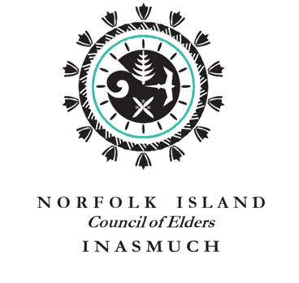

COUNCIL OF ELDERS ESTABLISHES LANGUAGE COMMISSION

Earlier this year, the Council of Elders endorsed a Language Revitalisation Strategy (2022-2025). An objective of the Strategy was to create a Norf’k Language Commission (NLC). The NLC commenced on the 8th June 2022; the 10-member Commission includes: Louise Tavener (Chair), Allen Bataille, Jane Rutledge, Joe Adams, Kane Anderson, Kristie Wilson, Merv Buffett, Ngaire Sheridan, Rebecca Hayes, and Wesley Quintal. Members serve a 2-year term on a voluntary basis. The establishment of the Commission coincides with the announcement by the UN General Assembly that 2022-2032 is the ‘International Decade of Indigenous Languages’

The NLC is working closely with Professor Peter Muhlhausler, who has been on the Island recently, on the production of a Norf’k dictionary. The Commission will also lead the implementation of the Language revitalisation Strategy. Although an independent body, the Commission will report to the Council of Elders on matters relating to the Norf’k language.

Any enquiries for the NLC; please contact Lou Tavener by email gonorfolkisland@gmail.com

The photo shows the NLC with Professor Muhlhausler at a welcome dinner at Jimbo & Lous home.

